Curriculum Vitae
personal Information
Name | Dr. Salma Ibrahim Abd ElRaouf El-Samannoudy | 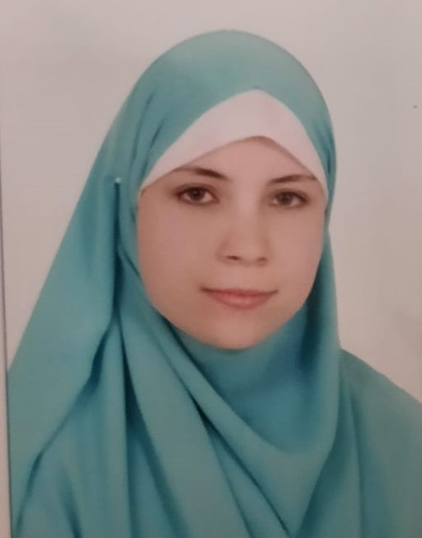
Title | Lecturer of physiology
Date of birth | 07 January 1986
Place of birth | Cairo
Citizenship | Egyptian
Contact Information
Home phone | 02-38752131
Work phone | 02-35720399
Mobile phone | 01001158317
E-mail (s) | Salma.elsamanoody@gmail.com  Salma.elsamanoody@vet.cu.edu.eg
Web site (s) | https://scholar.google.com/citations?view_op=new_articles&hl=ar
Current Address | 81 District (9) Neighborhood (4) Sheikh Zayed – 6th October
Educational Qualifications
Ph. D., physiology Faculty of Veterinary Medicine, Cairo University, 2017
M. Sc., Faculty of Veterinary Medicine, Cairo University, 2013
B. V. Sc., Faculty of Veterinary Medicine, Cairo University, 2008
Academic Positions
- Demonstrator in Physiology Department, Faculty of Veterinary Medicine, Cairo University (2009-2013).
- Assistant Lecturer in the Department of Physiology, Faculty of Veterinary Medicine, Cairo University (2013-2017).
- Lecturer of Physiology in Physiology Department, Faculty of Veterinary Medicine, Cairo University (2017 till now).

Thesis Title
M. Sc. | Physiological Studies On The Effect Of Exogenous Digestive Enzymes And Some Absorptive Enhancers On Growth Performance And Some Metabolic Parameters In Broilers
Ph. D. | Comparative Studies Of Some Natural And Commercial Feed Additives To Improve The Productive Efficiency Of Turkey Chicken.

Areas of experience
- Physiology
- Statistics
- Usage Of Blackboard

Membership of Cultural, Educational and Professional Societies:
- Member of staff of Physiology Dept. Faculty of Vet. Med., Cairo Univ.
- Member of Veterinary syndicate

Professional Qualifications
Conferences

12th “Hafez” International Symposium on Turkey Diseases 2018

Training courses
- Courses of the Faculty and Leadership Development Center at Cairo University:
1-Training course in Ethics Of Scientific search during the period of 1-3 February 2010 in Faculty and Leadership Development Center (FLDC), Cairo University.
2-4-Training course in Effective Presentation Skills which held during the period of 12-14 July 2010 in Faculty and Leadership Development Center (FLDC), Cairo University.
3-Training course in Technology Usage In Teaching which held during the period of 18-20 July 2011 in Faculty and Leadership Development Center (FLDC), Cairo University.
4-Training course in Meetings & Managing Time which held during the period of 20-22 April 2012 in Faculty and Leadership Development Center (FLDC), Cairo University.
5-Training course in Competing For Research Funds which held during the period of 25-27 march 2013 in Faculty and Leadership Development Center (FLDC), Cairo University.
6- Training course in Conference Organization which held during the period of 24-25 August 2013 in Faculty and Leadership Development Center (FLDC), Cairo University.
7- Training course in University Code Of Ethics which held during the period of 21-22 September 2013 in Faculty and Leadership Development Center (FLDC), Cairo University.
8- Training course in E- Learning which held during the period of 1-2 April 2014 in Faculty and Leadership Development Center (FLDC), Cairo University.
9- Training course in Change Management which held during the period of 16-17 January 2016 in Faculty and Leadership Development Center (FLDC), Cairo University.
10-Training course in Exam and Students Evaluation Systems which held during the period of 16-17 July 2016 in Faculty and Leadership Development Center (FLDC), Cairo University
11-Training course in University management which held during the period 28-29 September 2016 in Faculty and Leadership Development Center (FLDC).
12- Training course in Statistical Analysis Of Bio-experiment which held during the period of 8-9 november2017 in Faculty and Leadership Development Center (FLDC), Cairo University.
13- Training course in International Publishing Of Scientific Research which held during the period of 17-18 January 2018 in Faculty and Leadership Development Center (FLDC), Cairo University.

Computer Skills
Good command of computer skills(windows-internet-word-PowerPoint-excel)
Language Skills
Good command of English and French both writing and speaking.
List of publications
- Physiological Panel of Some Feed Additives for Turkey Toms. Sohair Y. Saleh ; Nahed S. El-Toukhy; Hassan. I. Abass; Salma I. El- Samannoudy, Mohamed A. Tony; Amin M. Hassanin Research and Development in Agricultural Sciences 2020 Vol. 2, Page 24-40
- Comparative studies of some natural and commercial feed additives to improve reproductive performance of turkey toms. Salma I. El-Samannoudy, H.I. Abass, N.S. El- Toukhy, S.Y. Saleh Veterinary Medical Journal 2017 Vol.63, page 83-90.
- Effect of multienzymes and absorption enhancers on productive performance, gut morphology and some blood biochemical and hormonal parameters in broiler chicks. Ahmed, H. H. ; El-Toukhey, N. S. ; Attia, K. A. ; El-Samannoudy S. I. Journal of Agricultural Science (Toronto) 2013 Vol.5 No.12 pp.162-179.

